Task on RDS
- Create MariaDB DB on EC2.
Steps:
- Open AWS Console, Go to EC2 → Launch Instance
Configure:
Name | Maria-db
AMI | Amazon Linux 2
Instance Type | t3.micro
Key Pair | Select
Security Group | Allow SSH (22)
Launch instance.
- Connect to EC2
- Install MariaDB
sudo yum update -y
sudo yum install mariadb105-server -y
Start service: sudo systemctl start mariadb
sudo systemctl enable mariadb
Check status: sudo systemctl status mariadb
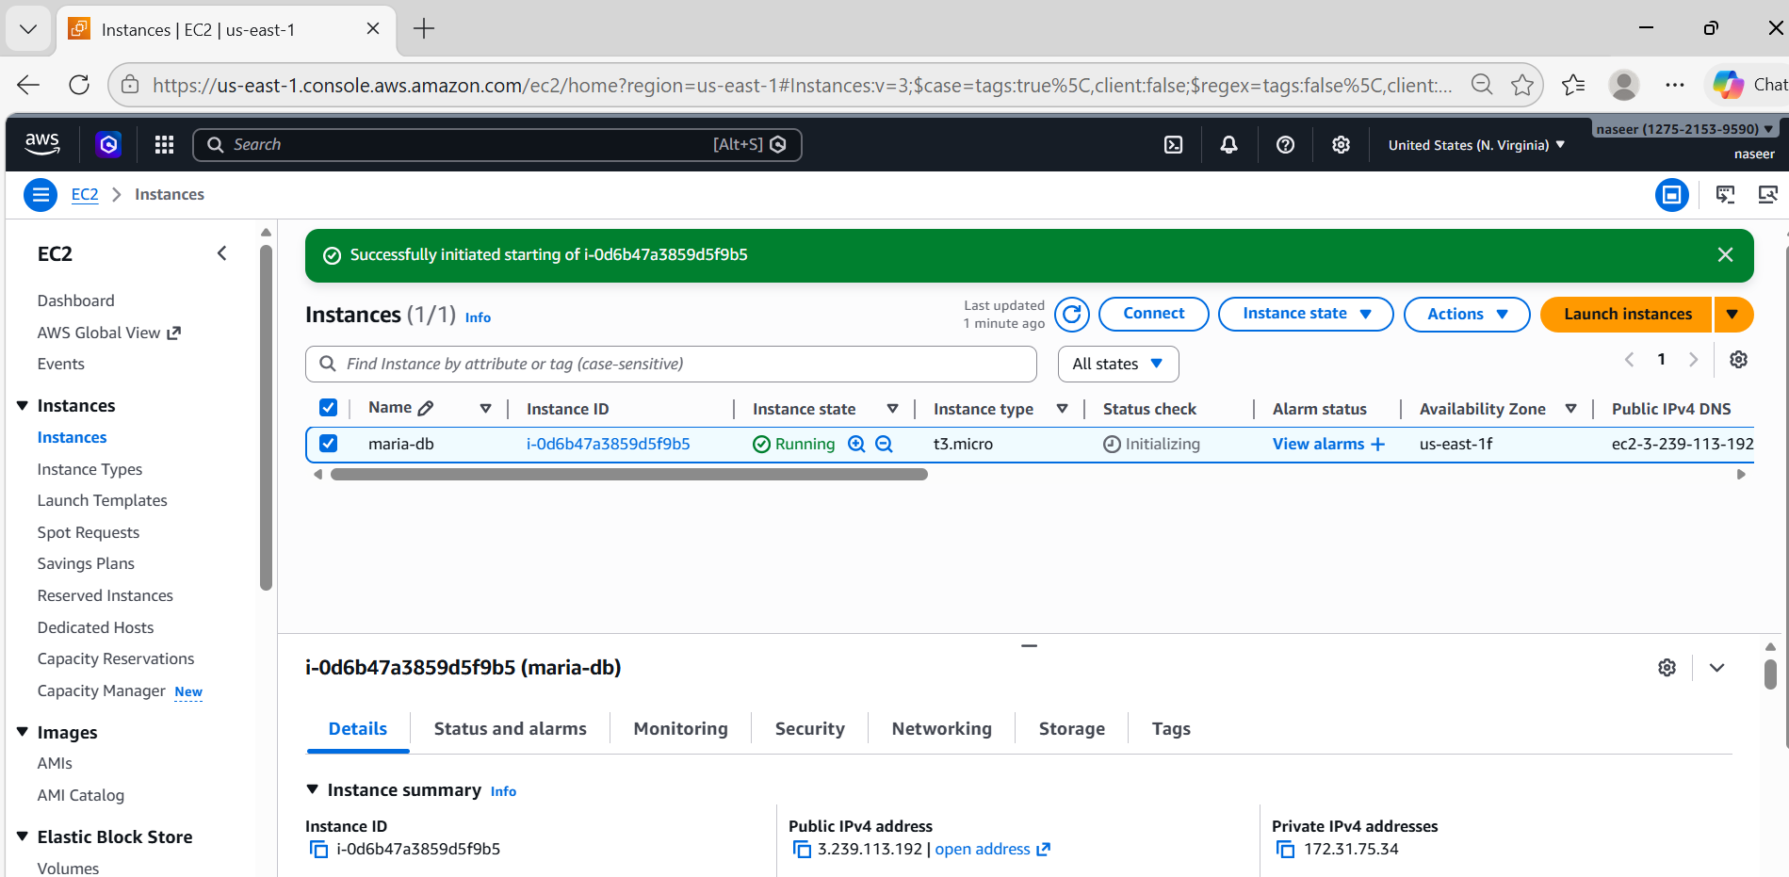

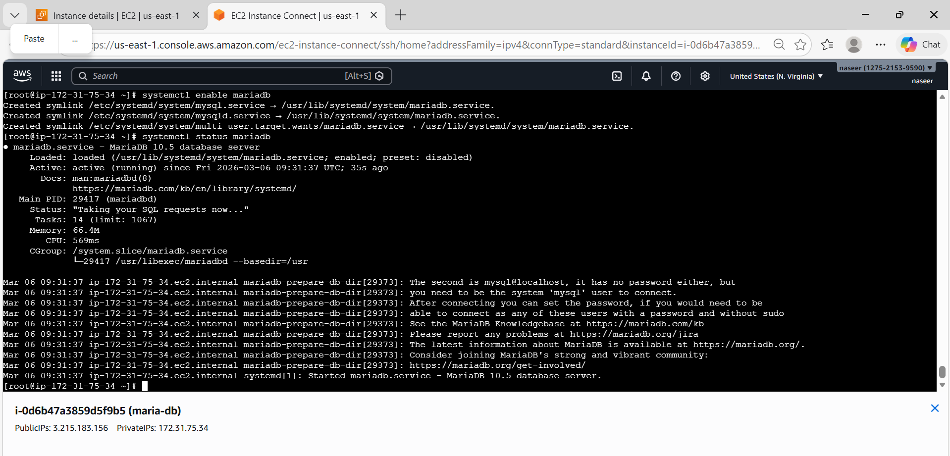
- Insert some dummy data.
Login to MariaDB
mysql -u root
Create database: CREATE DATABASE company;
Use database: USE company;
Create table
CREATE TABLE employee(
id INT AUTO_INCREMENT PRIMARY KEY,
name VARCHAR(45),
department VARCHAR(50)
salary INT);
Insert data
INSERT INTO employees(name,department,salary) VALUES
('rahul’,'IT’,’5000’),
('priya','HR',’45000’),
('amit,'FINANCE',’55000’),
(‘neha’,’IT’,’60000’);
Check data
SELECT * FROM employees;
exit
bye.
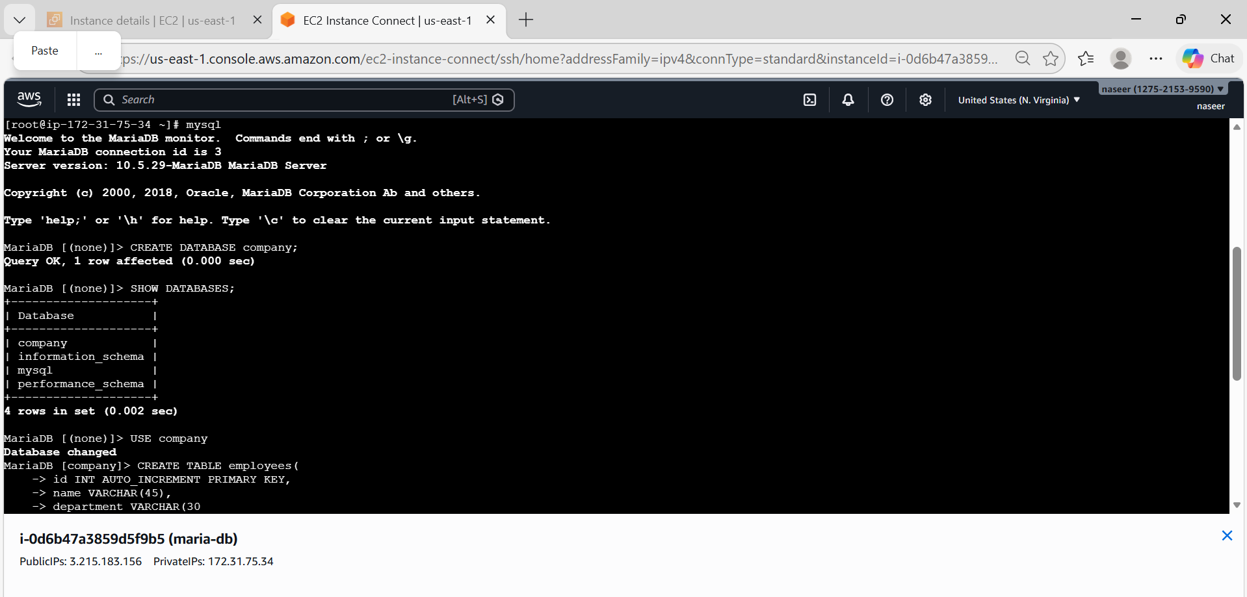
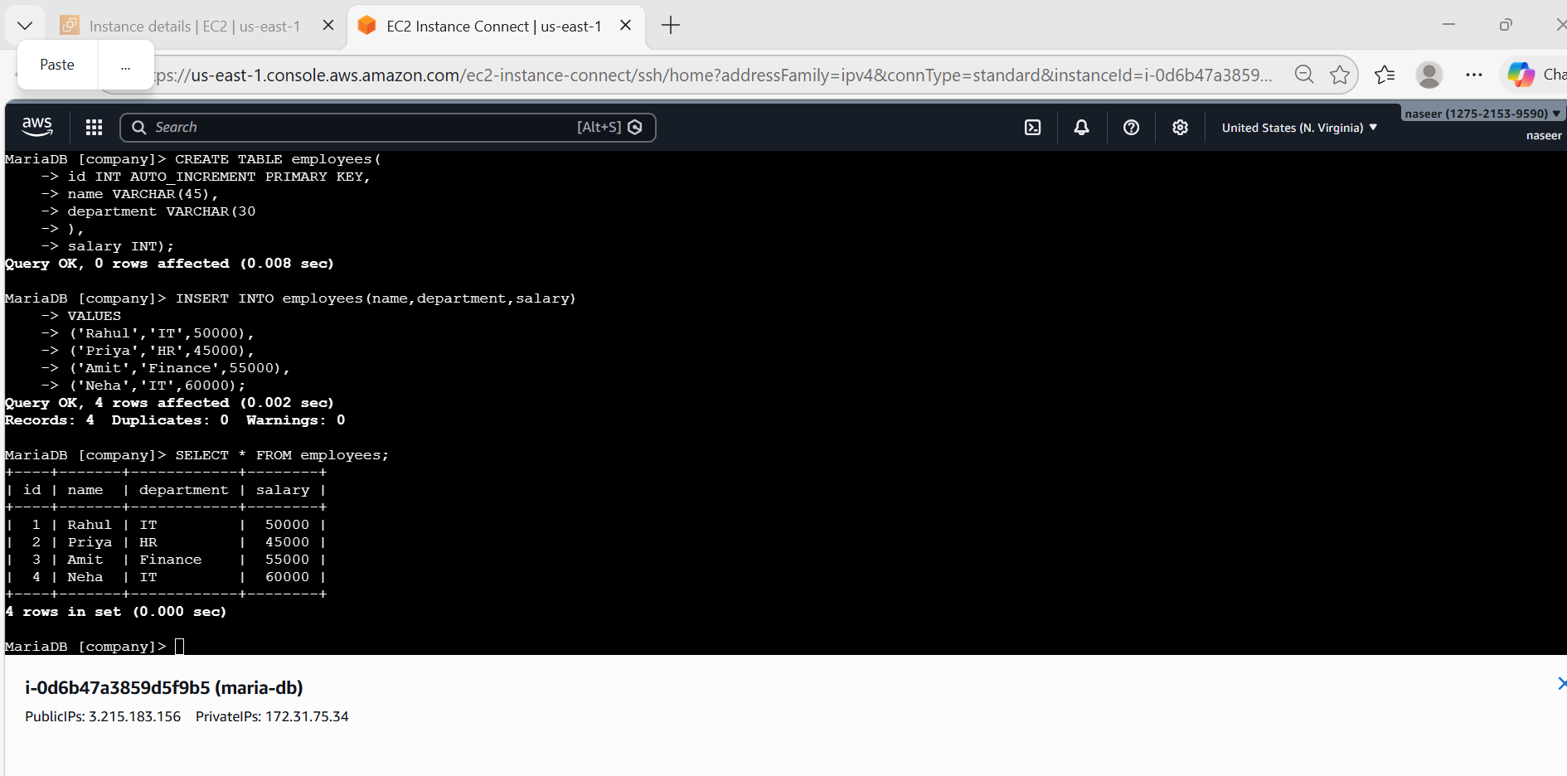
- Take the backup of dummy data on EC2.
Use mysqldump
mysqldump -u root company > company_backup.sql
Check backup file
ls
You will see
company_backup.sql

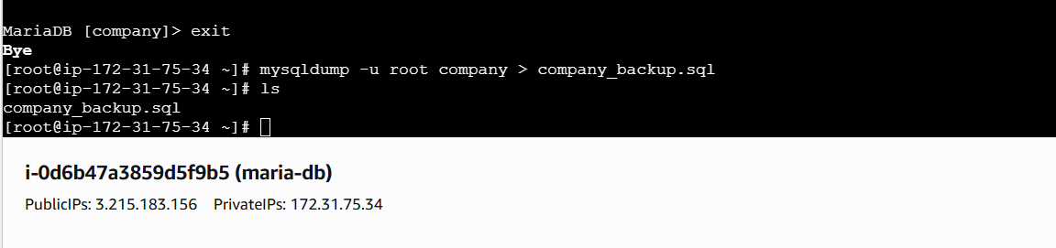
- Launch MariaDB RDS instance.
Steps:
- Login to AWS ConsoleSearch for RDSClick Amazon RDS
Select DatabasesClick Create Database
- Select Database Creation Method
Choose: Standard Create
Engine Type: MariaDB
Engine Version: MariaDB 11.8.5
Template Choose: Free Tier
DB Instance Identifier: database-1
Master Username: admin
Credentials Management
Choose: Self managed
Password: ********
Confirm the password: ********
Instance type: db.t3.micro
Storage Configuration
Storage Type: General Purpose SSD (gp2)
Allocated Storage: 20 GB
Availability & Durability
Do not create standby instance
Multi-AZ is mainly used for production environments.
Connectivity Configuration
Compute Resource
Select:
Don't connect to an EC2 compute resource
Network Type: IPv4
Select Default VPC and default public subnets(with different zones)
Public Access: Yes (This allows EC2 instances to connect to the database).
Select default VPC Security Group.
Monitoring Database Insights – Standard
Do not enable Enhanced Monitoring.
Additional Configuration
Keep default settings:
Clock on Create Database
Create Database
- The database status will show: Creating
After 5–10 minutes it will change to: Available
- Get Database Endpoint
Open RDS → DatabasesClick the created databaseCopy the Endpoint
Example: mariadb-rds.c4t8wcygkkgd.us-east-1.rds.amazonaws.com
Connect EC2 to RDSLogin to EC2 and run:
mysql -h RDS-ENDPOINT -u admin -p
mysql -h database-1.c2dyo20q8y88.us-east-1.rds.amazonaws.com -u admin -p
or
mysql -h database-1.c2dyo20q8y88.us-east-1.rds.amazonaws.com -u admin -p --ssl
Enter the database password.
Result
Successfully created a MariaDB RDS instance in AWS and configured it for database connectivity.
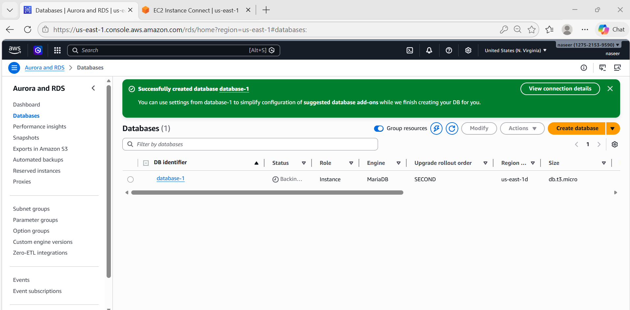
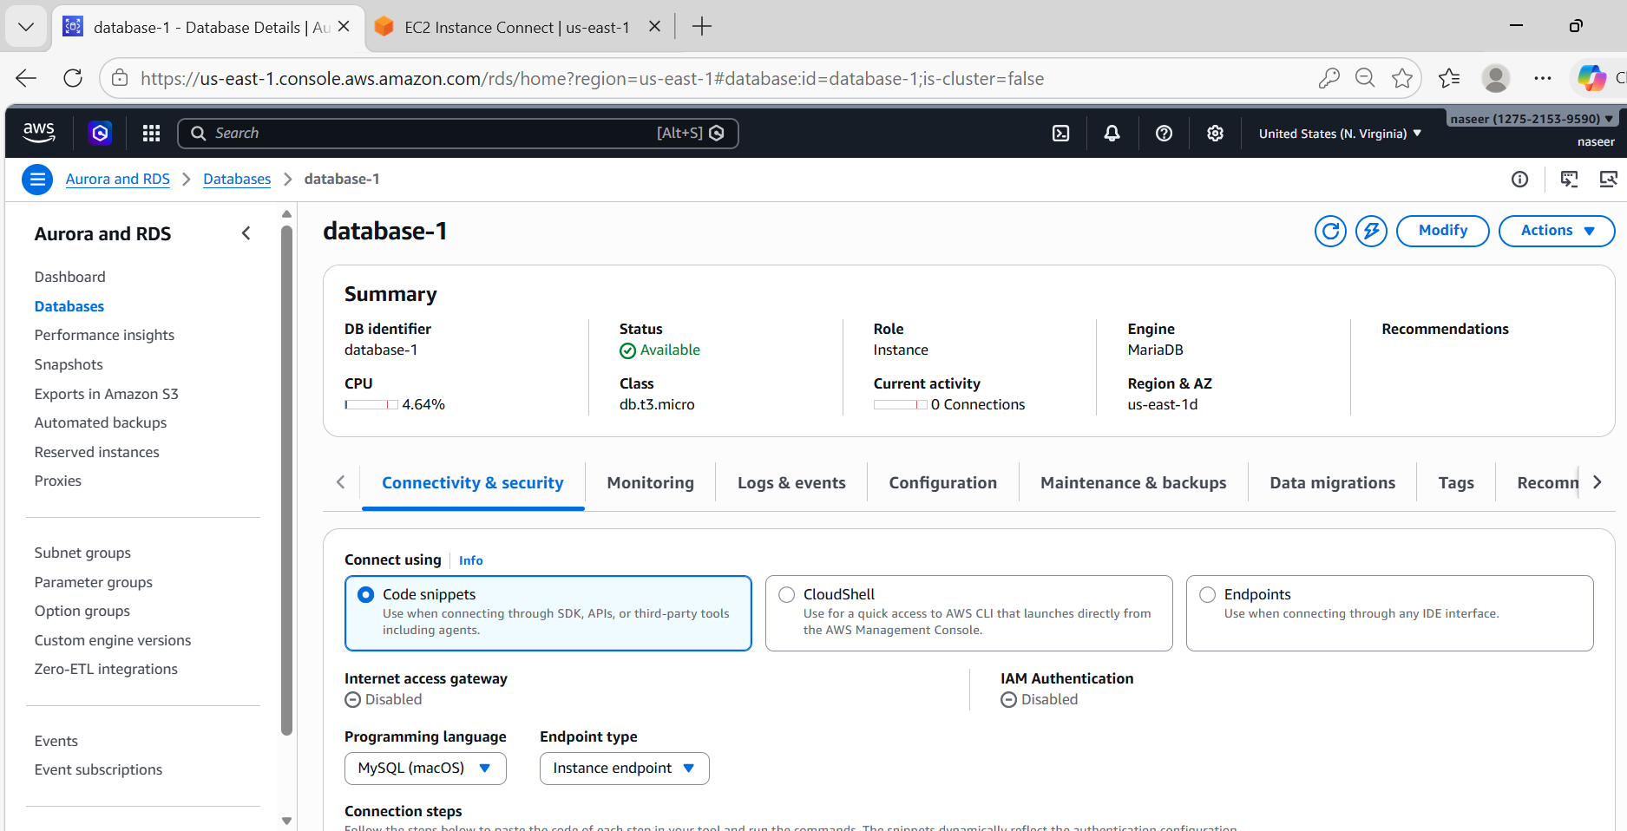
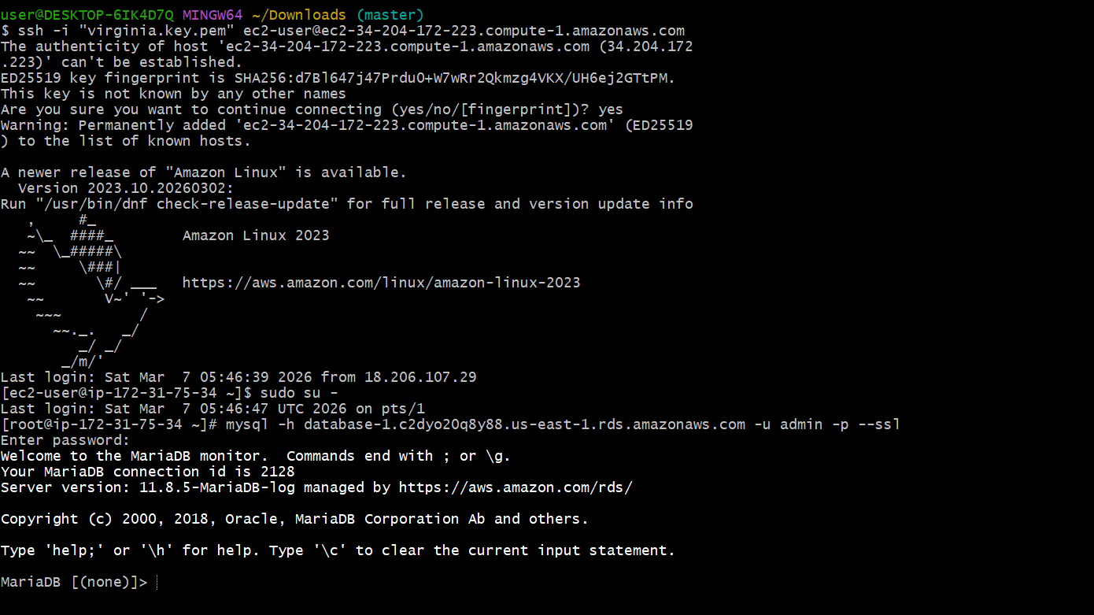
- Migrate database from EC2 to RDS.
Get RDS Endpoint
database-1.c2dyo20q8y88.us-east-1.rds.amazonaws.com
Now restore backup.
mysql -h database-1.c2dyo20q8y88.us-east-1.rds.amazonaws.com -u admin -p company < company_backup.sql
Enter password: ********
Now data is migrated.
Verify:
mysql -h <RDS-ENDPOINT> -u admin -p
USE company;
SELECT * FROM employees;

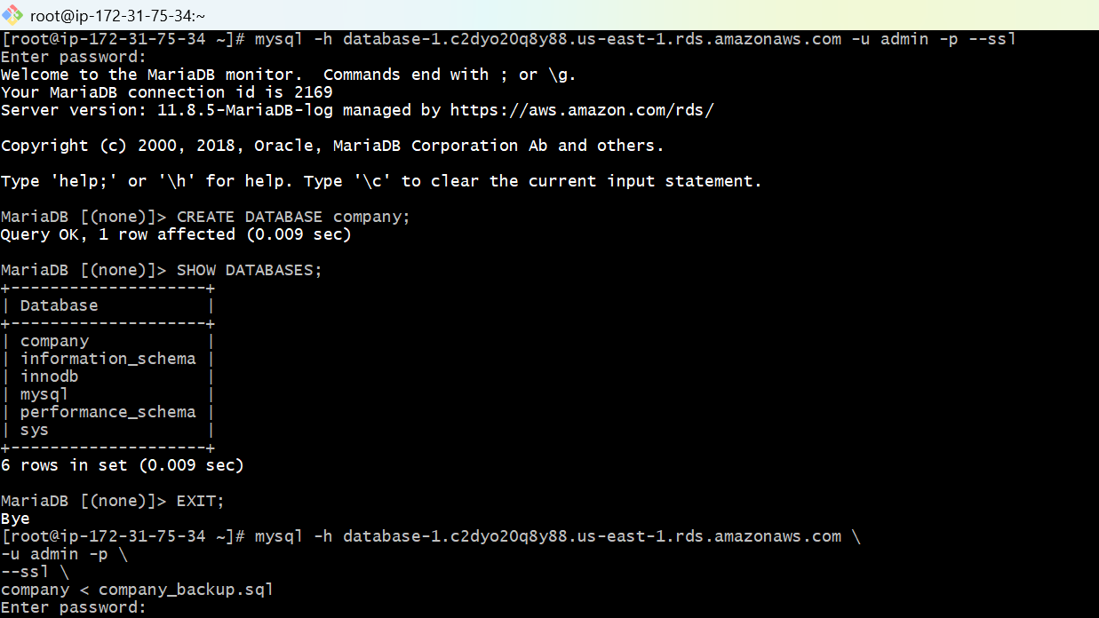
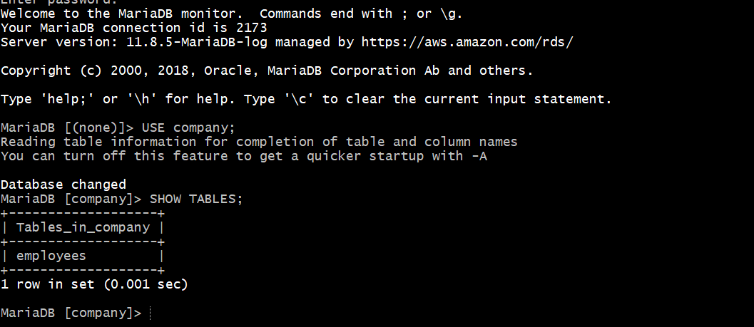

- Install MySQL DB on EC2.
Install MySQL
-sudo dnf update -y
-sudo dnf remove mariadb* -y
-sudo dnf clean all
-sudo dnf install mysql-community-server -y --nogpgcheck
This installs:
- mysql-server
- mysql-client
- mysql-libs
- mysql-plugins
-sudo mysqld --initialize --user=mysql
-sudo systemctl start mysqld
-sudo systemctl enable mysqld
-sudo systemctl status mysqld
You should see:
active (running)
Get temporary root password
-sudo grep 'temporary password' /var/log/mysqld.log
Example output:
temporary password: dFyhgu8TLr!
- Login to MySQL
-mysql -u root -p
Enter the temporary password.
Change root password
Inside MySQL run:
-ALTER USER 'root'@'localhost' IDENTIFIED BY 'Admin@123';
-SHOW DATABASES;
You will see:
Exit MySQL
exit

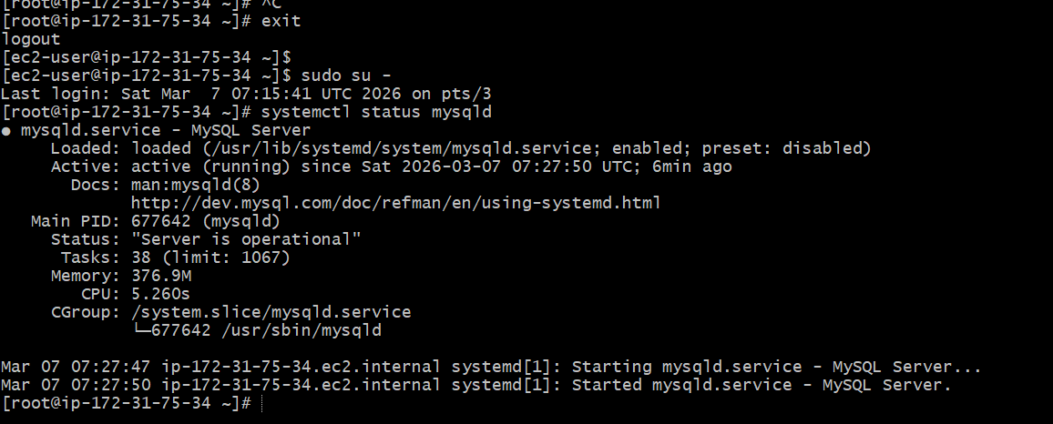
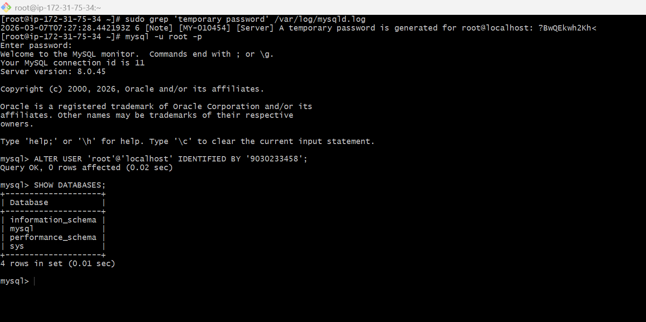
- Launch MySQL RDS image.
Steps:
- Login to AWS ConsoleSearch for RDSClick Amazon RDS
Select DatabasesClick Create Database
- Select Database Creation Method
Choose: Standard Create
Engine Type: mysql
Engine Version: MySQL 8.4.7
Template Choose: Free Tier
DB Instance Identifier: database-2
Master Username: admin
Credentials Management
Choose: Self managed
Password: ********
Confirm the password: ********
Instance type: db.t3.micro
Storage Configuration
Storage Type: General Purpose SSD (gp2)
Allocated Storage: 20 GB
Availability & Durability
Do not create standby instance
Multi-AZ is mainly used for production environments.
Connectivity Configuration
Compute Resource
Select:
Don't connect to an EC2 compute resource
Network Type: IPv4
Select Default VPC and default public subnets(with different zones)
Public Access: Yes (This allows EC2 instances to connect to the database).
Select default VPC Security Group.
Monitoring Database Insights – Standard
Do not enable Enhanced Monitoring.
Additional Configuration
Keep default settings:
Clock on Create Database
Create Database
- The database status will show: Creating
After 5–10 minutes it will change to: Available
Go to RDS → Databases → database-2
Copy the Endpoint.

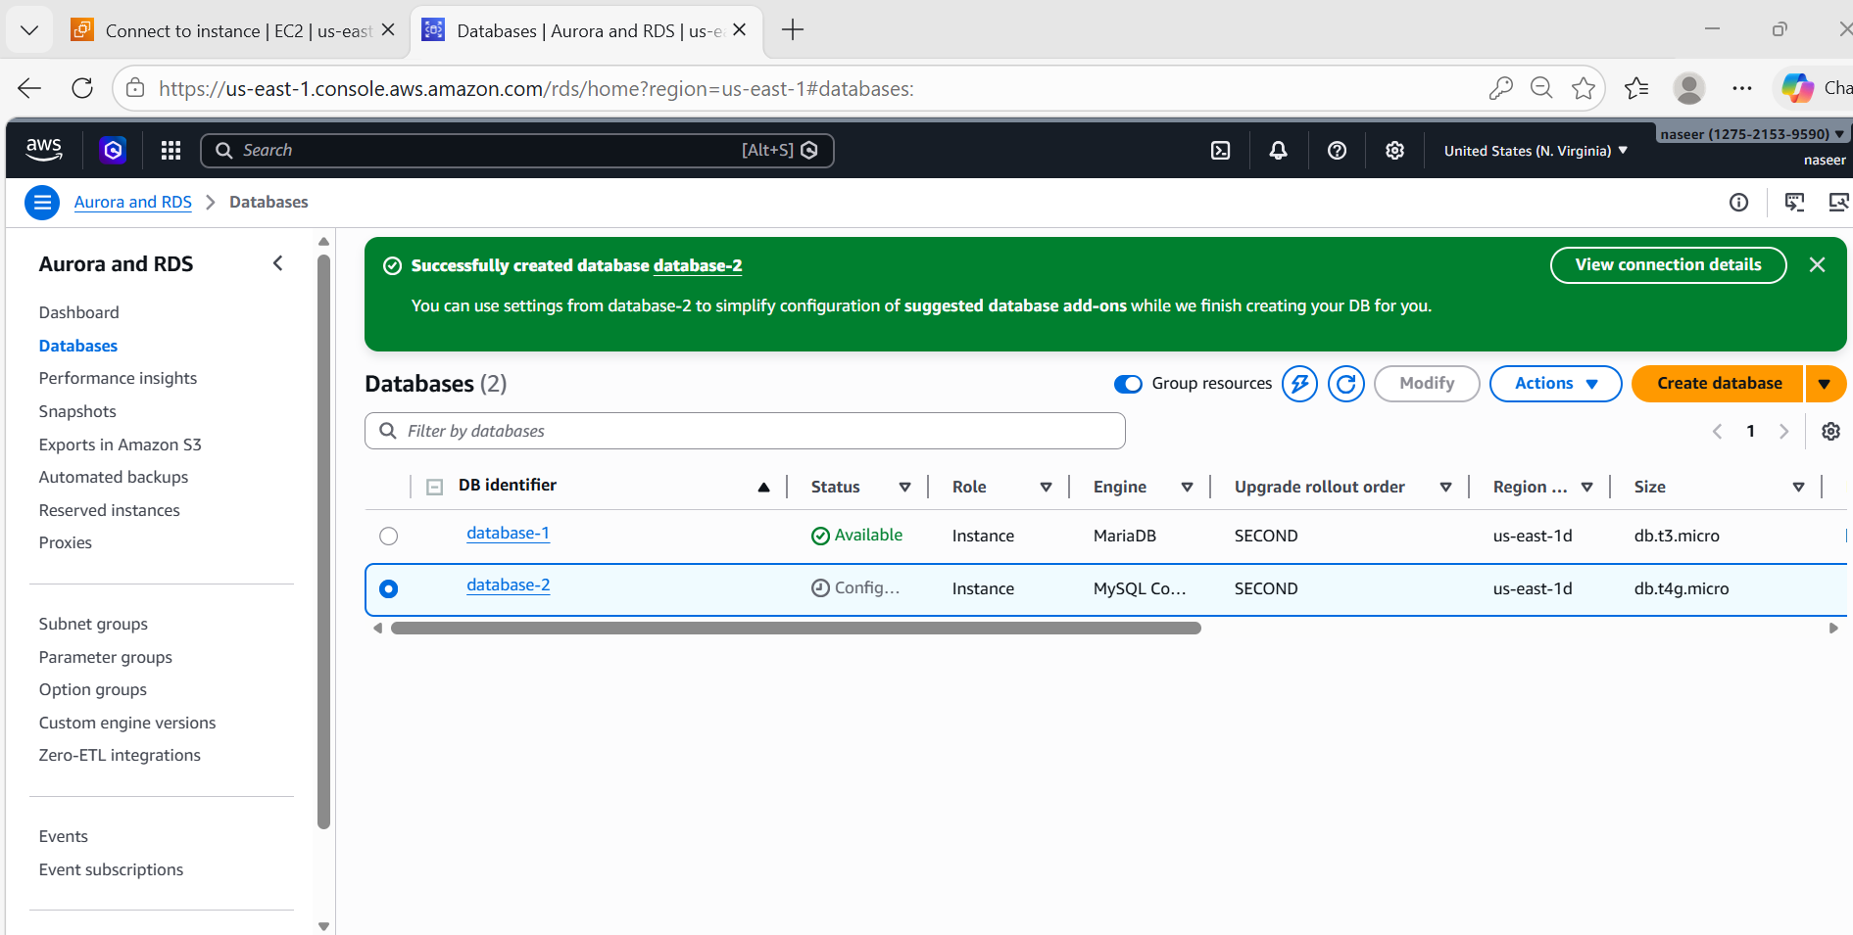

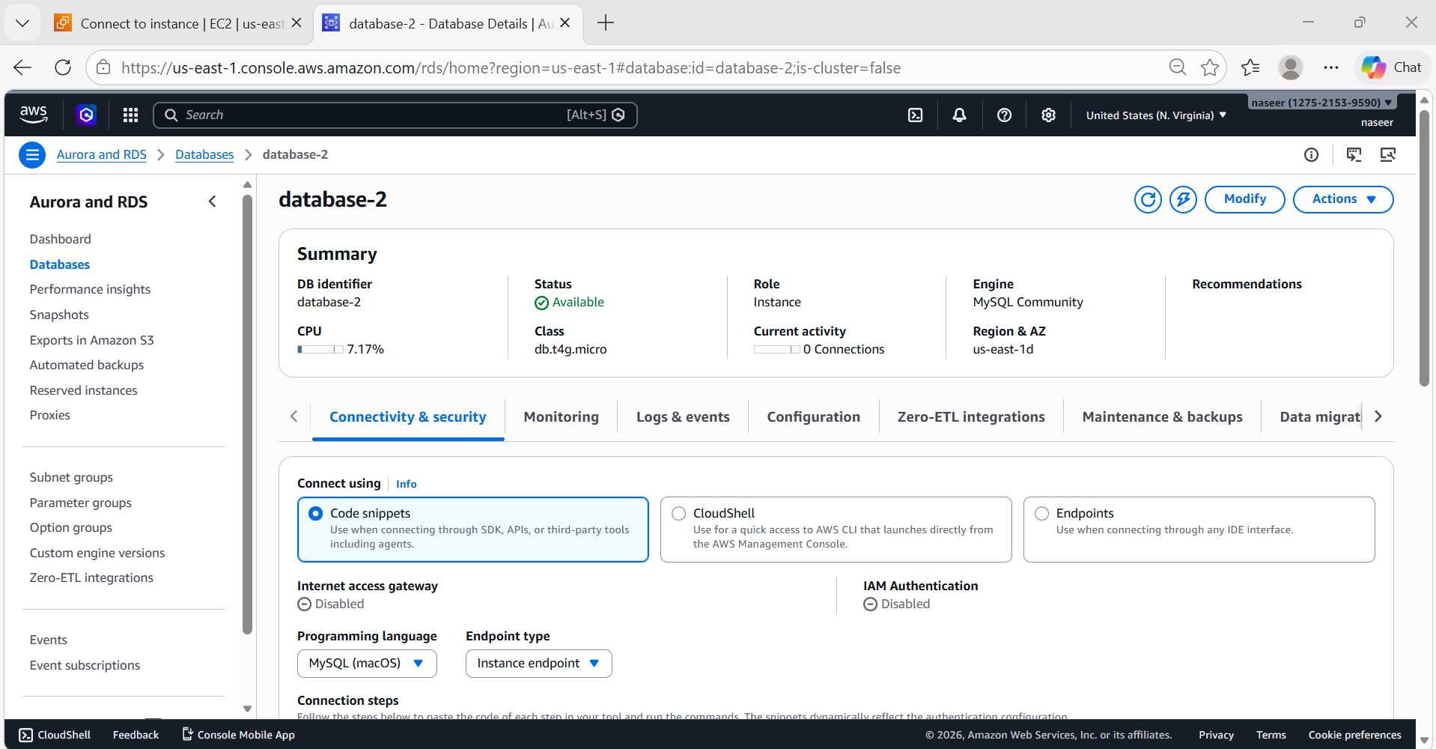

- Configure Multi-AZ.
Steps:
Go to RDS → DatabasesSelect mysql-rdsClick on ModifyAvailability & Durability
Enable: Multi-AZ deployment and click continue Then Apply Immediately.
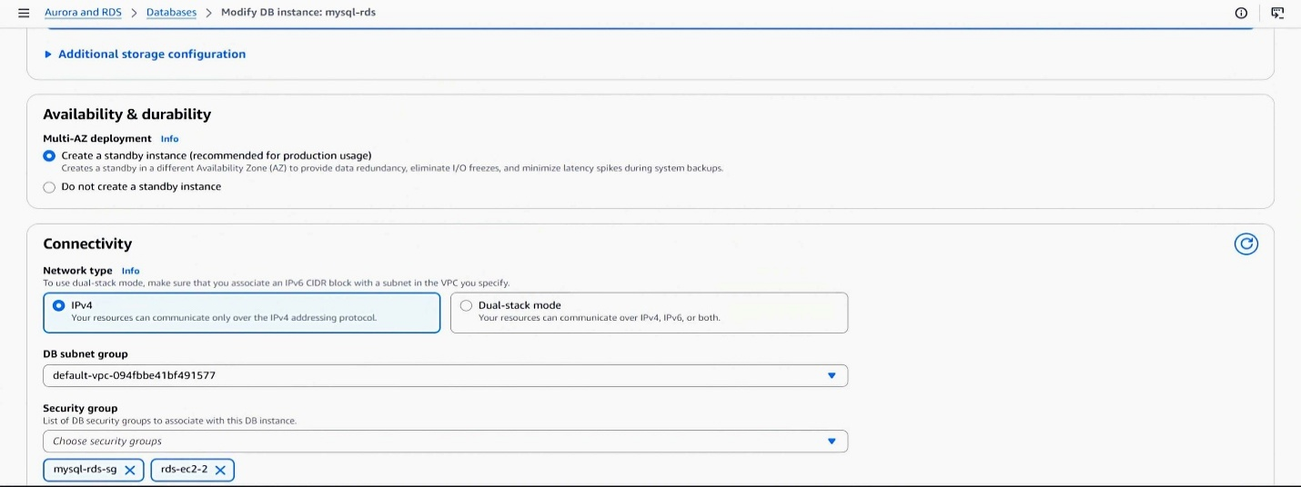
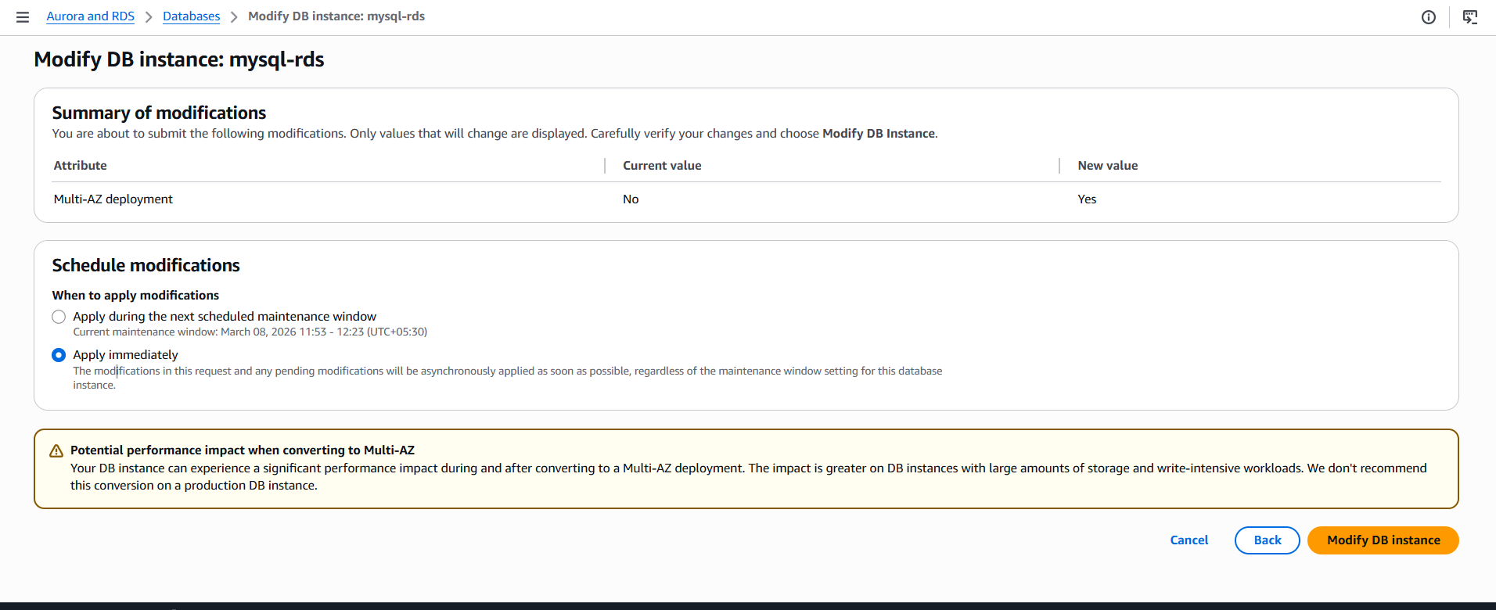
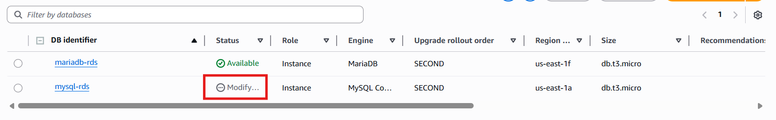
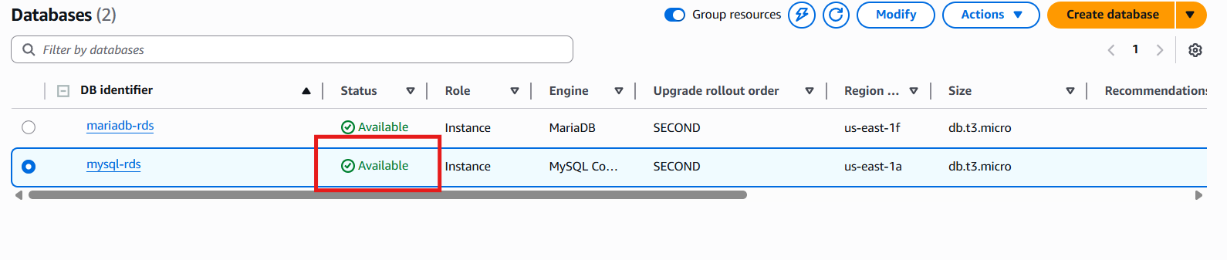
- Take backup of DB and restore the DB.
Go to RDS → Databases select database-1
Actions → Take Snapshot
Snapshot Name: backup-8776756
Create Snapshot
Restore DB
Go to SnapshotsSelect backup-8776756Restore Snapshot
Restore
Now a new DB instance will be created.

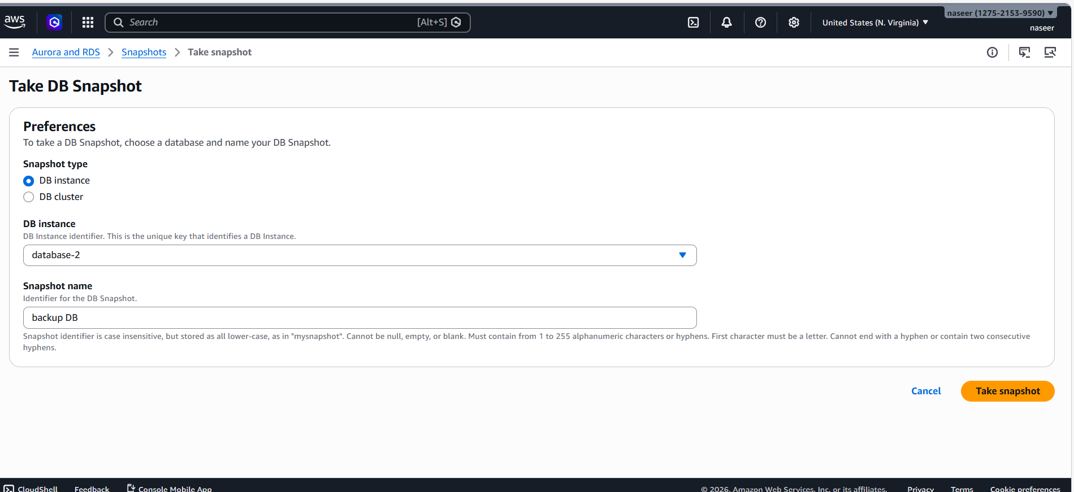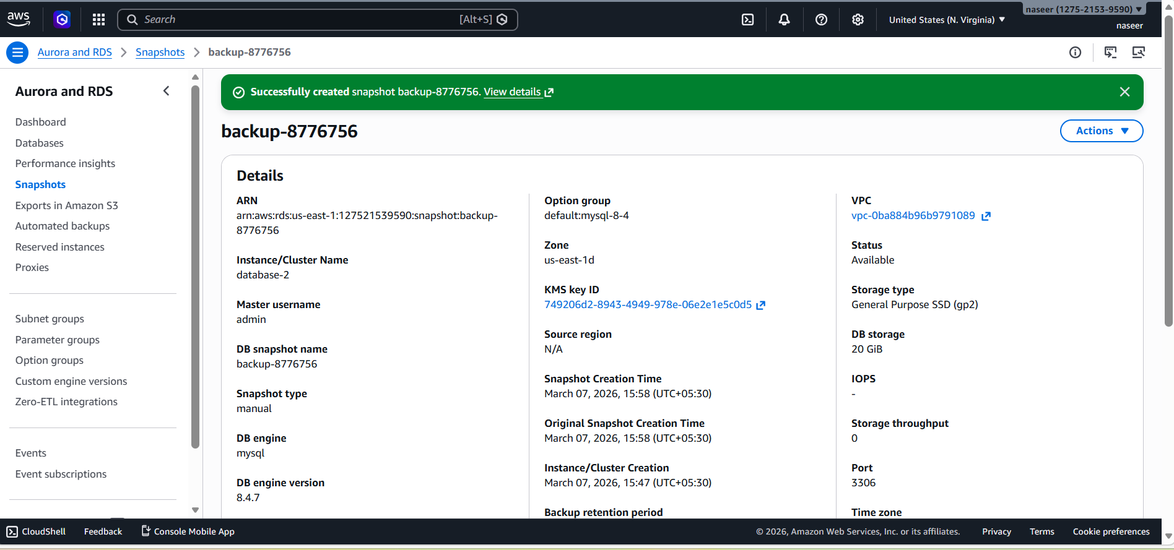
- Create read replica.
Steps:
Go to RDS → Databases
Select database-1Actions → Create Read Replica
Replica DB Name:database1-replica
Instance type: db.t3.micro
Create Read Replica

